Histograms
A population histogram allows us to compare _________________ and ____________________ within a population.

These histograms can help us to determine ____________________ in a population.
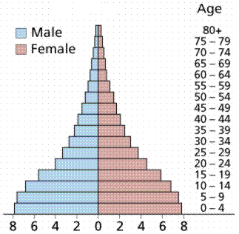

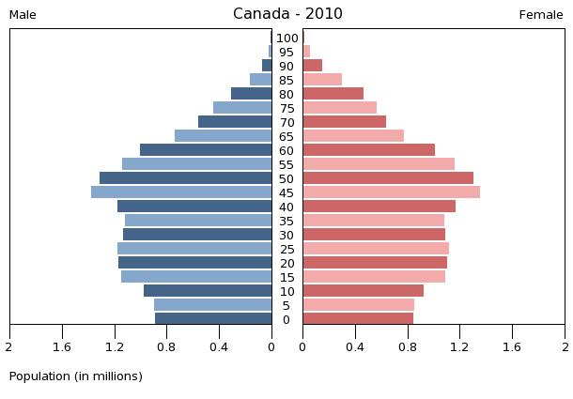
Population Growth
Open population: Population in which organisms are free to come and go (immigrate and emigrate)
◦ex: _______________ , _________________
Closed population: Population in which immigration or emigration ______________ naturally occur.
◦ Ex: ________________
Natality: ________________
Mortality: ________________
In order to determine the _____________________ in a population over time, scientists use a ____________________ ______________________ _________________.
This formula considers 4 factors:
◦
◦
◦
◦

Population Growth Formula
Population Growth = (births + immigration) - (deaths + emigration)

PG = (B+I) – (D+E)

Remember: This formula gives us the population ________________ or _________________ in population. The formula does __________________ determine the actual number of organisms in the population.

Population Growth Problems
It has been a cold year and a population of coyotes is feeling the effects. During the year 12 pups were born, but 5 died. 9 coyotes left the population to find more food, however, the pack welcomed 2 from the pack across the river. What was the population growth?
PG = (B+I) – (D+E)

- Biologists want to study population growth of ladybugs in two weeks. In a small ecosystem 137 ladybugs die and 213 are born. 187 leave the population and 98 immigrate in. What is the change in population?

- In a flock of migrating Canada Geese, 28 decide to stop in California and not come home. 9 die on the hard journey home. Back in Winnipeg, 36 new chicks are born and 12 join in from another flock. What is the population growth at the end of the season?

- If we know that the population of geese was 96 at the beginning of the migration, what is the population now?

