Mythbusters Dodge a Bullet:
Reflexes Notes

The Nervous System:
Your body’s systems carry out the processes that keep you alive - your digestive system helps supply the fuel you need, your immune system keeps you from getting sick, and your muscular system lets you move around.

The _____________ keeps them all connected and working together. It’s made of two parts, the ______ and _________ nervous systems that work together to send electrical and chemical messages around the body very quickly.

The Central Nervous System:
The central nervous system contains your ________ and _________. Your peripheral nervous system contains _________ that ________ _________ from your body and send it to your brain, and ________ __________ from the brain to the rest of the body.

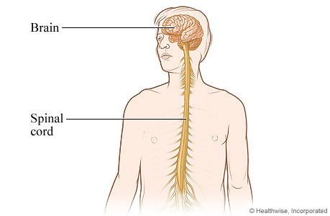
The _________ connects the brain to the rest of the body. It runs from the brain down to the small of the back and is responsible for_____________, which are automatic behaviors that require no input from the brain.
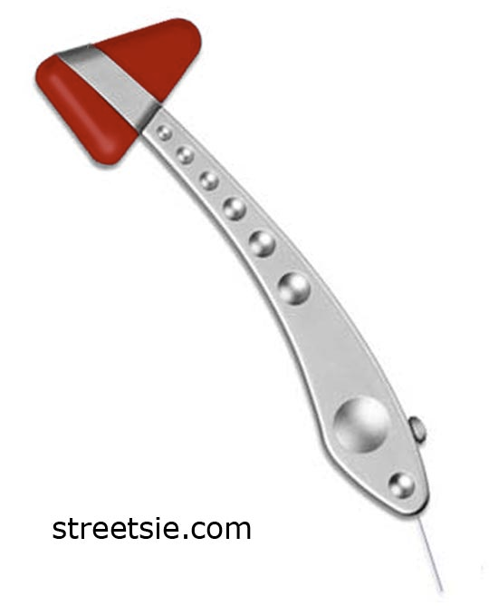
Example of spinal reflexes: __________________ _________________.
These reflexes have ancient origins and allow the body to respond quickly to threats and hazards without the time delay involved when the brain is consulted about how to respond to a stimulus.

The spinal cord also sends messages ______________ to the other parts of the body and_________________ back to the brain.
The _________ is the main organ in the nervous system. It integrates information from the senses and coordinates the body’s activities. It allows people to remember their childhoods, plan the future, create term papers and works of art, talk to friends, and have bizarre dreams. Different parts of the brain do different things.
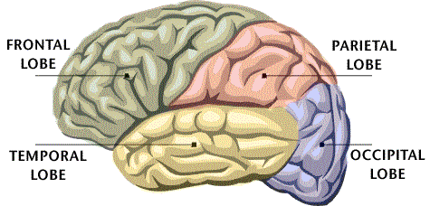
_______________: Concerned with reasoning, planning, parts of speech and __________, emotions, and problem-solving.

________________: Concerned with perception of stimuli such as touch, pressure, temperature and pain.

________________: Concerned with perception and recognition of auditory stimuli (hearing) and memory.

________________: Concerned with many aspects of __________.

Peripheral Nervous System:
All the parts of the nervous system except the brain and the spinal cord belong to the peripheral nervous system. The peripheral nervous system has two parts:

- the ____________ nervous system
- the _____________ nervous system.

The Somatic Nervous System: consists of nerves that connect the central nervous system to voluntary skeletal muscles and sense organs. Voluntary skeletal muscles are muscles that help us to move around.

The Autonomic Nervous System: consists of nerves that connect the central nervous system to the heart, blood vessels, glands, and smooth muscles. Smooth muscles are involuntary muscles that help organs such as the stomach and bladder carry out their functions. The autonomic nervous system controls all the automatic functions in the body, including breathing, digestion, sweating, and heartbeat.

Your peripheral and central nervous system both play a role in helping you catch the ruler, using the following steps:
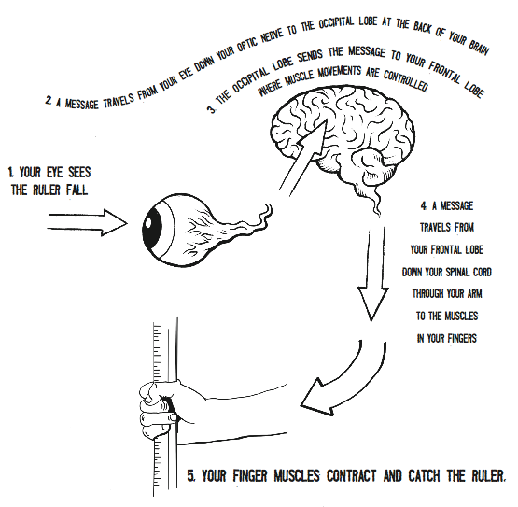
And that all happens in less than a quarter of a second!
SO WHY ARE SOME PEOPLE FASTER THAN OTHERS?

It has to do with practice. The more times you do something, the faster and more accurate you get. When you first learned to tie your shoes or type on a keyboard, it probably took a while. After a while, using the same nerves over and over trains them (and your muscles) to perform the task.

