Science 20F
Your Turn to be the Teacher!
In this project, you will essentially be making a lesson for the class on one of the following topics:
Thunder storms
Tornados
Hurricanes
Climate Change

Your lesson must include:
- Presentation (15 min): Use power point for your presentation, but feel free to include videos, demonstrations, questions for the class, or even little activities to do along the way.
- Student notes: These should follow along with your presentation. They should include all the important information the class needs to know. You may use fill in the blank if you wish.
- Assignment (1 page): This will be handed out after your presentation to assess whether or not the class understood what you taught.
Depending on the topic your group chooses, there are specific details you must include. Anything else you may choose to add is extra!
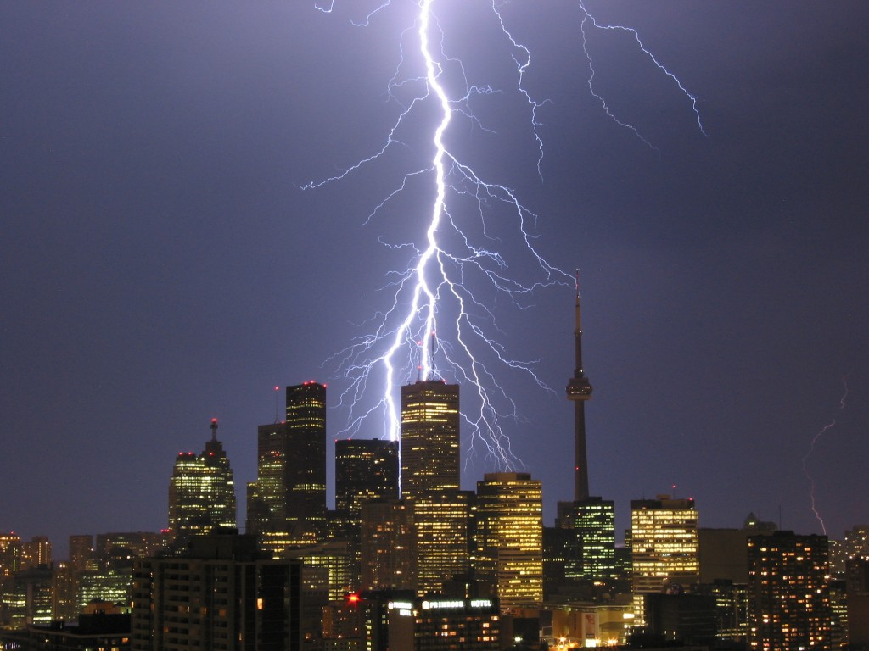
Thunderstorms
- Interesting facts
- Stages of development (include details and diagrams)
- Safety practices
Tornados
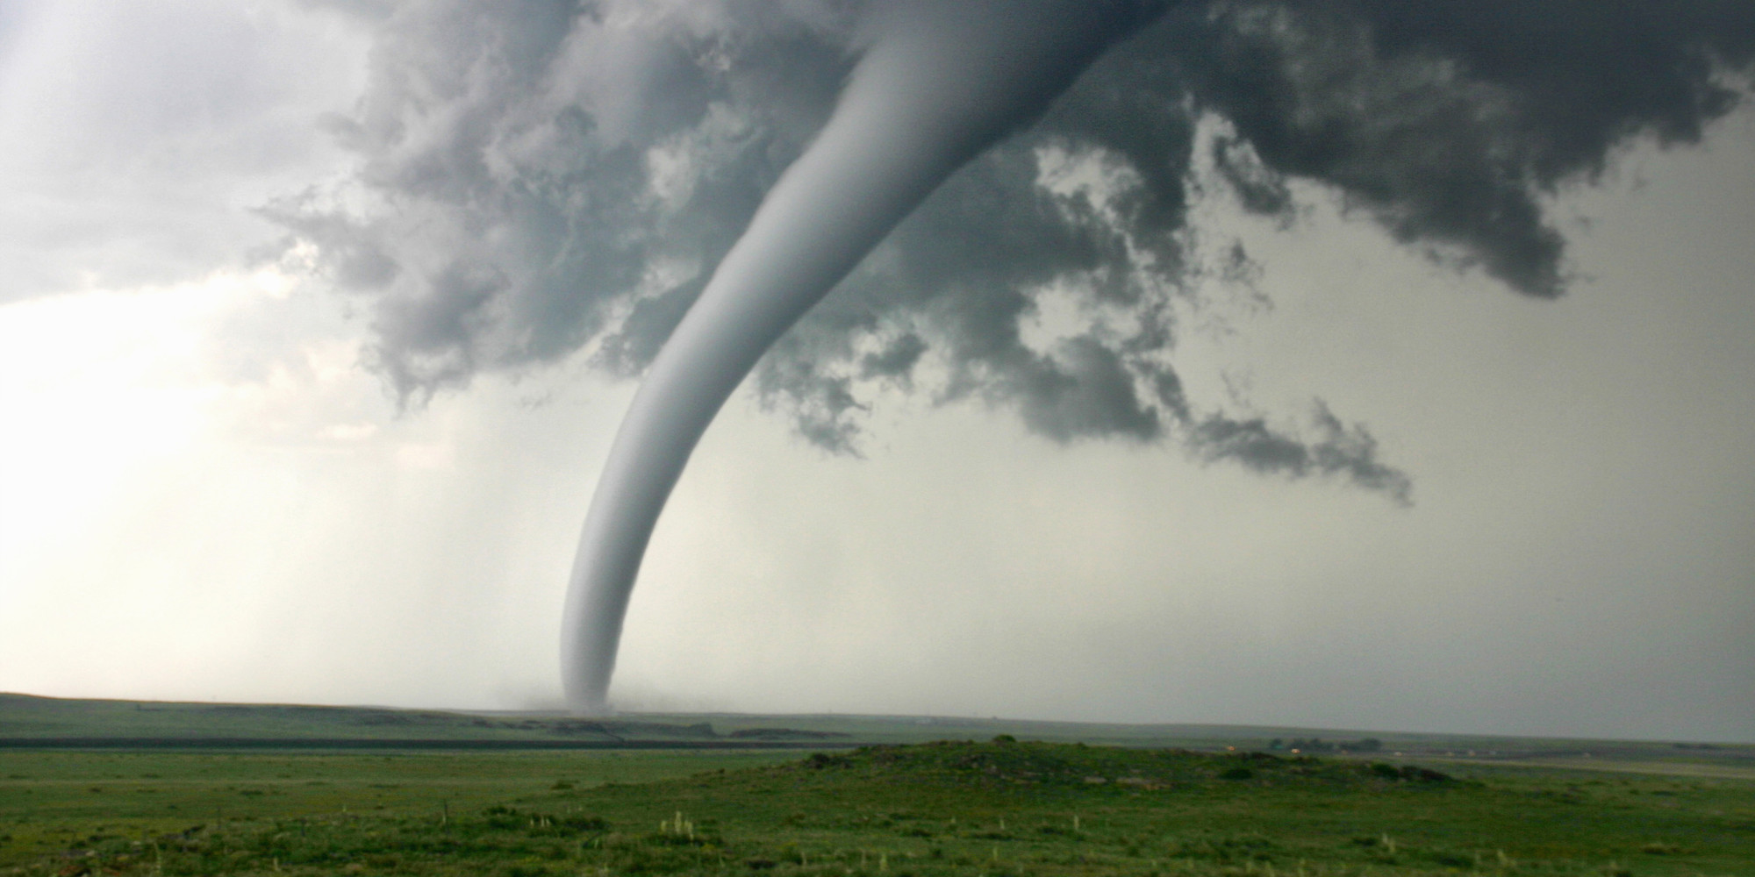
- How they are formed
- Classification (Fujita Scale)
- Safety practices
Hurricanes
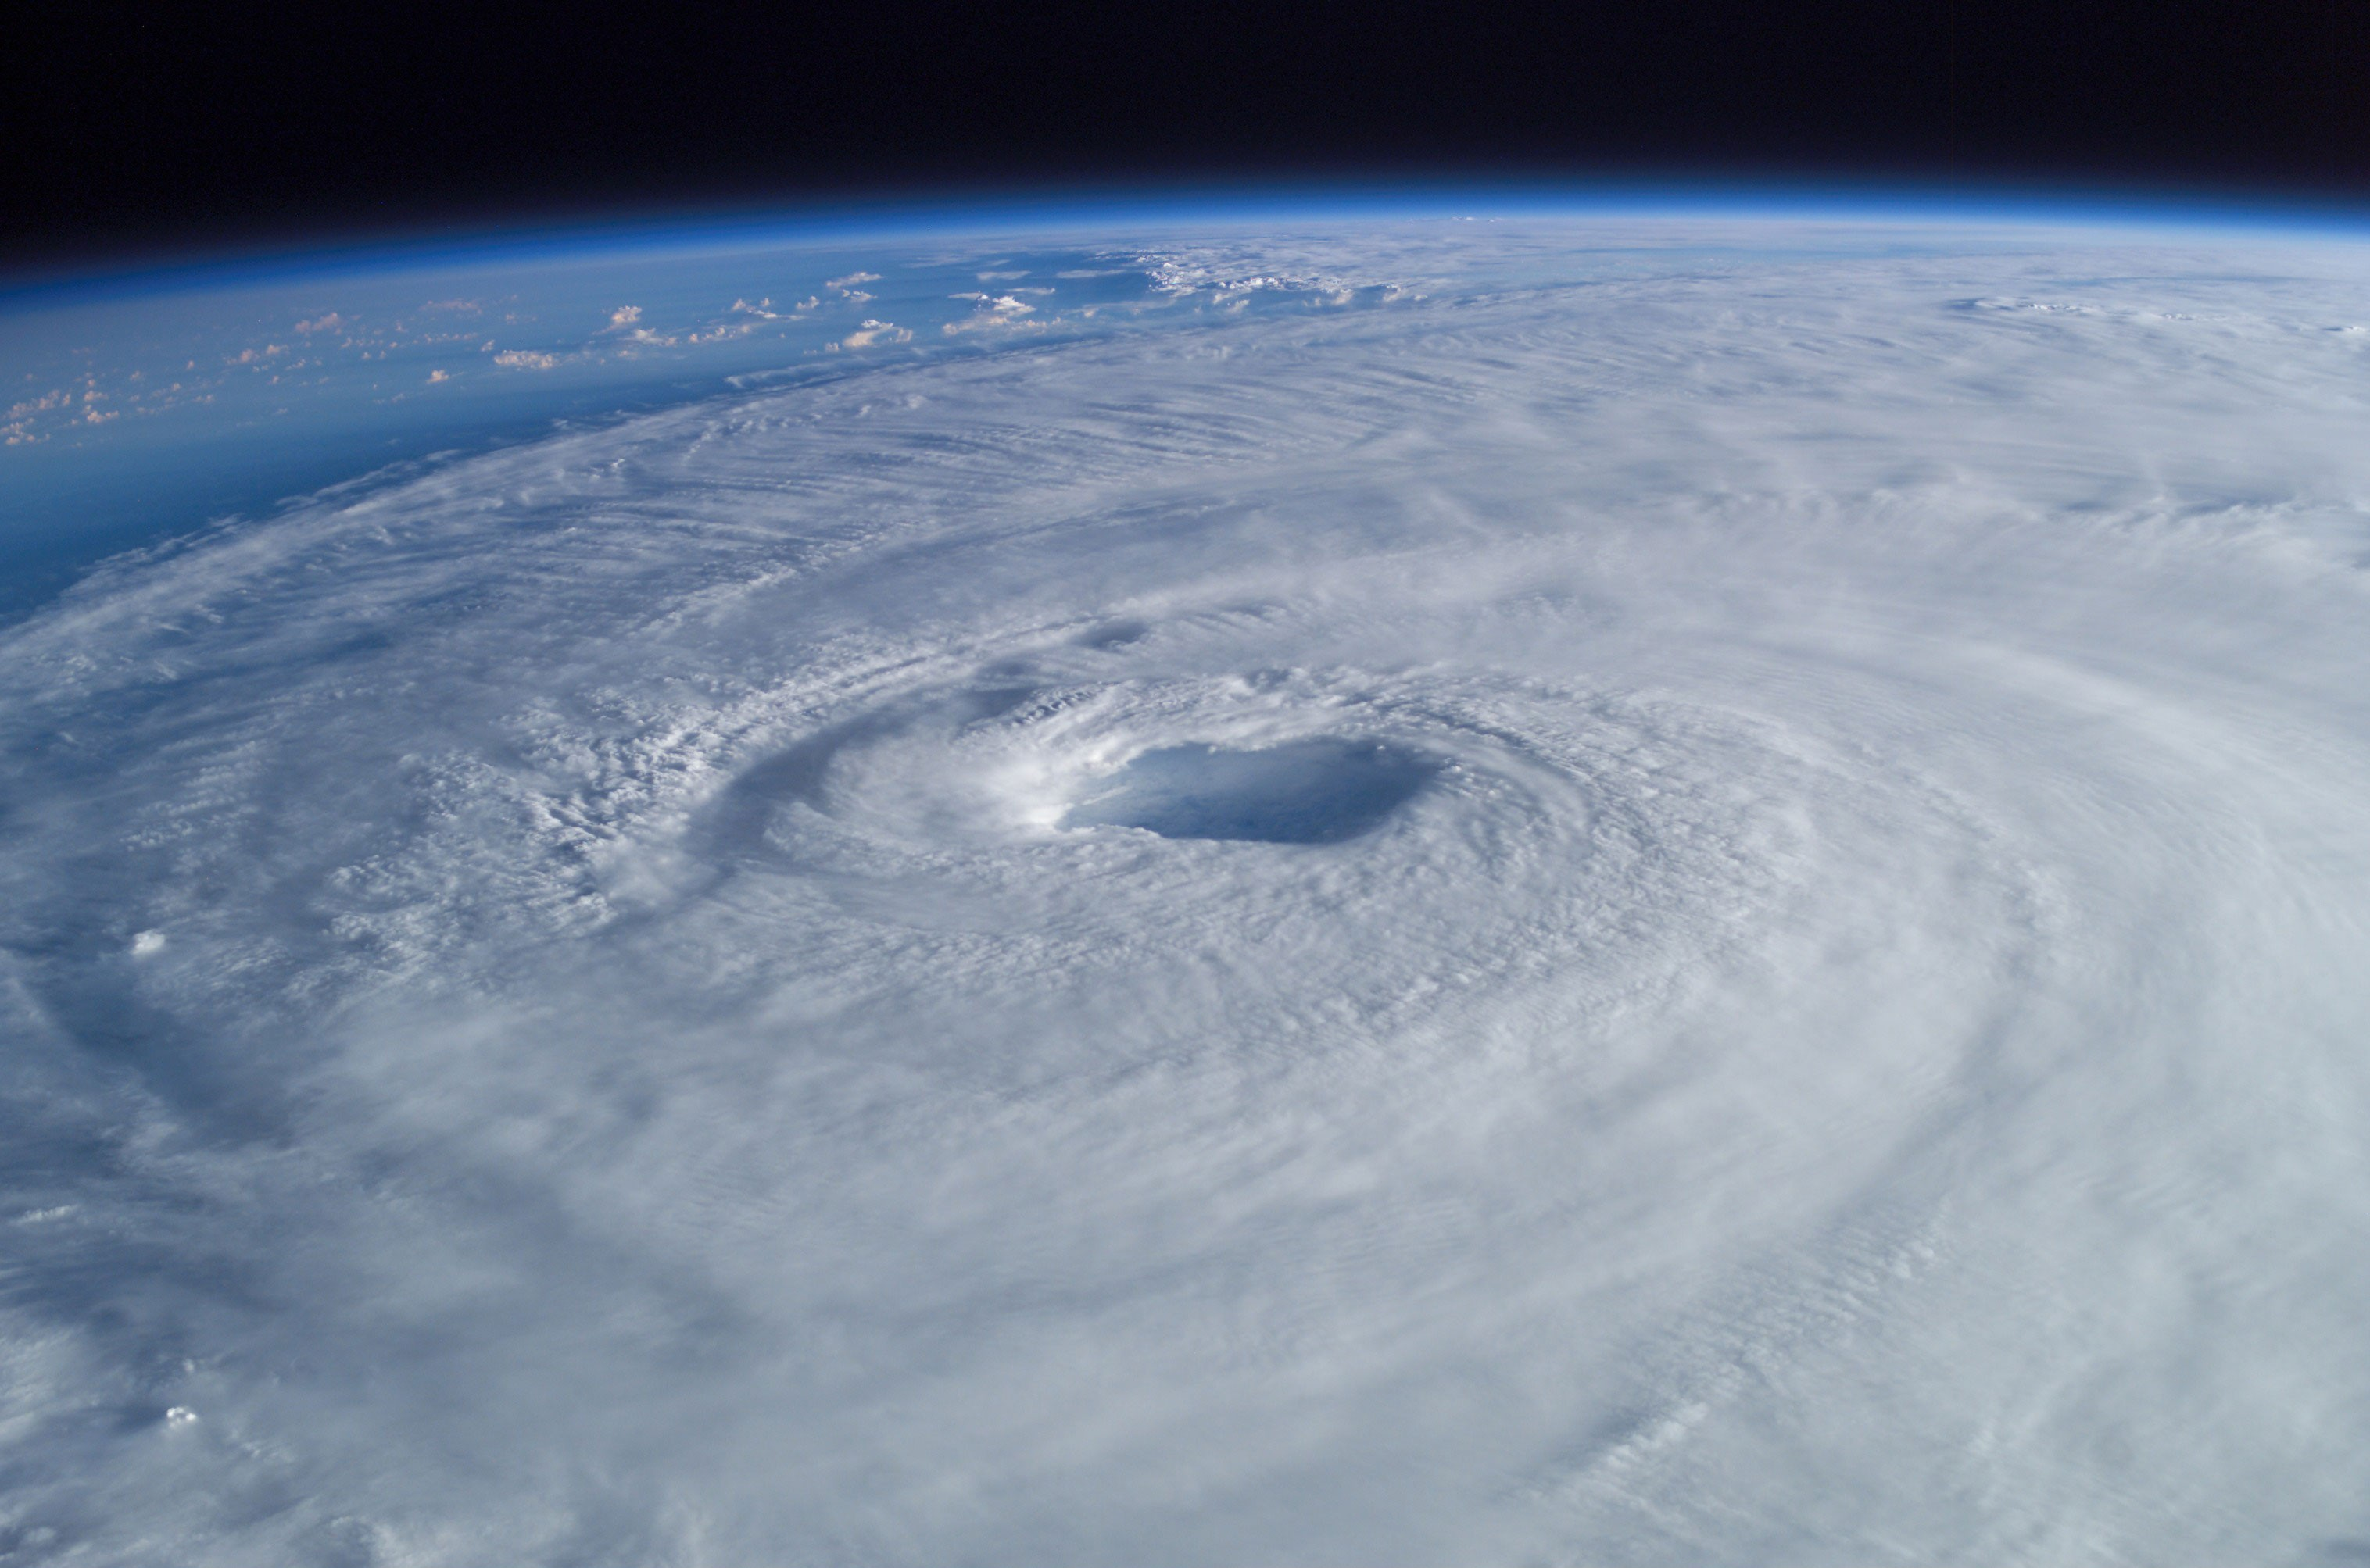
- Conditions required for a hurricane
- Stages of development
- Features of a hurricane (include diagram)
- Classification (Saffir-Simpson scale)
Climate Change
- Difference between weather and climate
- Natural Climate change (global history)
- Climate change caused by humans (include cause and effect, predicted trends)
Evaluation
Your group will be graded based on the content of your presentation, your delivery, and your assignment.
These are the questions I will consider when awarding marks:
- Were you organized and prepared?
- Did you keep your learners in mind?
- Was the lesson interesting and engaging?
- Did you speak with a clear voice and good pace?
- Did your assignment check for student understanding of what you taught?

