Under Seige!!!
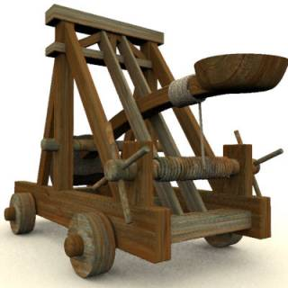

Deep into the Middle Ages, your king is planning an attack against a hostile, but well fortified enemy nation. The castle walls are thick, and you have been called to the task of constructing a catapult to tear the walls down. Distance, accuracy, and durability will be key to the design and function of your catapult. You have a limited time to complete the task or deal with the disapproval of your king!

Phase 1: Choose your team

Your team will consist of three members: design specialist, materials manager, and book-keeper. Select the members of your team with these roles in mind. Read the description for each role and decide who is best suited for each responsibility. Record the names in the space provided.

Design Specialist: Responsible for laying out a sketch of the catapult with any required measurement, labels, or notes. Must include the rationale for the design in the final report.

Name ____________________________

Materials Manager: Responsible for determining what materials are needed and how many of each. Must purchase these materials and make them available to his group. Must include the rationale for the chosen materials in the final report.

Name ____________________________

Book-keeper: Responsible for creating an estimate for how much the catapult construction will cost, and keeping track of the materials purchased throughout construction. Must include a budget statement in the final report.

Name ____________________________

Phase 2: Create your proposal

Do not rush this phase. Any plans you create must be approved by your king (teacher) before you proceed to the construction phase. Your proposal must include a detailed drawing of the completed catapult including any measurements and instructional notes necessary to make it clear how the catapult will be constructed. You must consult the materials list to determine what supplies are available and how much they cost. A complete estimate for the number of each material needed as well as the cost are required. This must be done in a neat and orderly fashion.

Materials List
Material | Cost
Wooden dowel | 50 Denucs
Pencil | 45 Denucs
Rubber band (thick) | 5 Denucs
Rubber band (thin) | 3 Denucs
Glue stick (large) | 35 Denucs
Glue stick (small) | 7 Denucs
Metal parts (hooks etc) | 20 Denucs
Plastic parts (pop lid, spoon) | 15 Denucs
Marble | 10 Denucs
Popsicle Stick | 20 Denucs
Paper clip | 1 Denucs
String (1 meter) | 5 Denucs
Clothes pins | 25 Denucs
Garden wire (1 meter) | 10 Denucs
Pipe cleaner | 5 Denucs

Phase 3: Construction

You must work quickly and carefully. Each day the materials manager must purchase supplies and the book-keeper must keep a careful record of the money spent.

Phase 4: Battle!!!

There will be several tests to determine the worthiness of your catapult.
- Distance – you have 3 chances to see how far your projectile flies
- Accuracy – you have 5 chances to hit a target 5 meters away (castle)
- Cost efficiency – you will receive more credit for low cost

*** If your catapult breaks during battle and requires repairs, you will receive a deduction.

Phase 5: Report

Your final report must include a discussion and evaluation on the design and materials used for the catapult. What worked well and what could be improved? The budget summary must also be included, as well as a comment on the money spent including suggestions on how money could be saved.

Date | Materials |  | Amount |  |  | Cost
Total

